**25th INTER-PARLIAMENTARY MEETING IPM25**

European Parliament, Brussels &

House of Representatives of Belgium, Brussels

Ein Bild, das Text, Screenshot, Grafiken, Logo enthält.

SPONSORSHIPS

**ALL YOU NEED TO KNOW BEFORE SPONSORING**

EUROPEAN FORUM FOR

RENEWABLE ENERGY SOURCES

[www.eufores.org](http://www.eufores.org)

ABOUT EUFORES

Why sponsor

EUFORES events?

[**EUFORES**](https://eufores.org/) is a European cross-party network of Members of Parliament from the European Parliament as well as from the EU27 national and regional Parliaments. With the objective of promoting **renewable energy** and **energy efficiency**, EUFORES is supported by a variety of non-parliamentary members, scientific institutes, energy agencies and NGOs - all strongly committed to its mission. In order to coordinate the exchange between its members, EUFORES has developed a broad spectrum of activities, among them, the [**Inter-Parliamentary Meetings**](https://eufores.org/category/events/inter-parliamentary-meetings/).

ABOUT EUFORES CONFERENCES

Since 1995 EUFORES has held high-level conferences throughout the European Union – both on the European and the national level. They have become an important forum for the parliamentary community to exchange information on the latest developments in renewable energy and energy efficiency and formulate energy addressing policies through a community-driven policy development process. These conferences provide a great opportunity for knowledge sharing and professional networking.

Join EUFORES

Engage with

the European parliamentary network

At these high-level conferences, parliamentarians as well as other stakeholders from the renewable energy and energy efficiency sector have the chance to discuss the issues at hand.

**Sponsors** are thereby in touch with a highly engaged European audience of **key decision-makers** in the sectors of renewable energy and energy efficiency.

#### **WHAT IS IN IT FOR ME?**

**📣 Advocacy**: High visibility among policy makers and especially Parliamentarians from all over Europe

**🌐 Influence:** Being part of the discussion about Europe’s energy future

**🤝 Networking:** Networking opportunity to discuss the possibilities and needs of your sector with national and European Parliamentarians

🎯 **Positioning:** Building up your company’s profile among key decision makers

Stand out from the rest!

**Do not miss out**

**on these great opportunities!**

## 

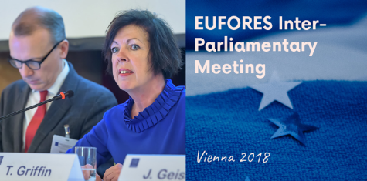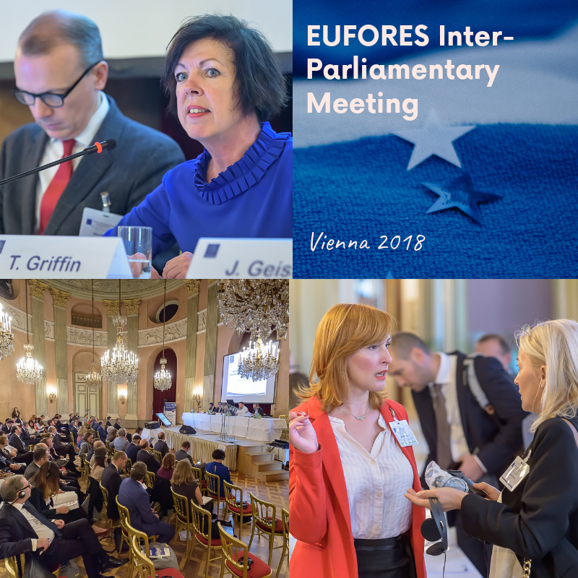

## **AUDIENCE**

EUFORES events attract over 100 participants from all over Europe ranging from members of parliament to civil society representatives.

EUFORES events are endorsed by Members of the European Parliament (MEPs) and Members of national Parliaments (MPs), Members of Regional Parliaments, as well as European Commission and national or local governments.

Among the attendees are key technical experts responsible for policymaking and for technological development in the field of renewable energy and energy efficiency.

Claude Turmes, former MEP and Honorary President of EUFORES

IPM Participants

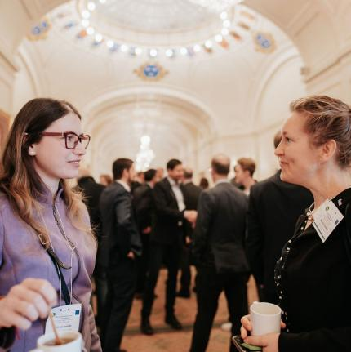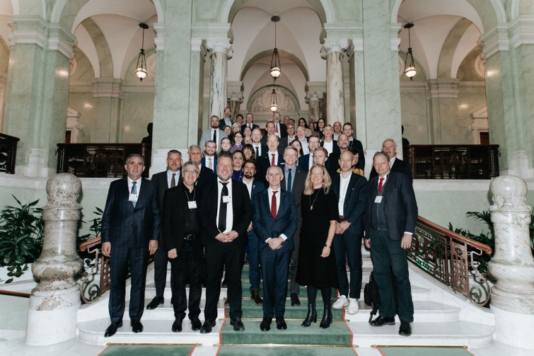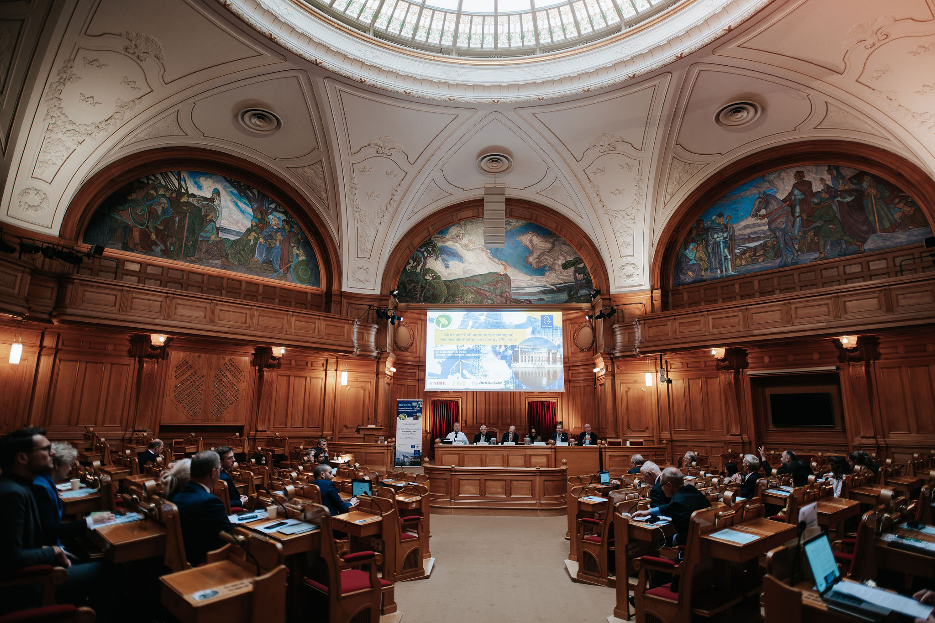

**EUROPEAN PARLIAMENt**

**EUROPEAN COMMISSION**

**Eu nATIONAL PARLIAMENTS**

**regional parliaments**

**GOVERNMENT DEPARTMENTS**

**scientific community**

**CIVIL SOCIETY**

**COMPANIES**

**EUROPEAN and national**

**ASSOCIATIONS**

## [**25th Inter-Parliamentary Meeting on Renewables and Energy Efficiency (IPM25)**](https://eufores.org/events/ipm25-brussels/)

European Parliament, Brussels and

the House of Representatives of Belgium, Brussels

**20-21 March 2025**

## 

Stand out from the rest!

**Sponsorship Opportunity**

**Participants**

Members of the European Parliament, Members of Parliaments of the EU27, parliamentary civil servants, government representatives, EUFORES non-parliamentary members, selected high level experts.

**Information**

IPM25 is organized in close cooperation with both the European Parliament and the House of Representatives of Belgium as a tandem conference in Brussels. It is a closed high-level political event. The conference will discuss core topics on European and national level related to the energy transition:

* European Clean Industrial Deal
* The Importance of Electrification
* Development of Grids
* Renewable Energy Directive
* Energy Efficiency Directive
* Energy Performance of Buildings Directive
* Consequences of the Ukraine war for the energy transition
* National implementation of EU policies
* Exchange of experience between EU and national levels and between national parliaments

Interested in knowing more? Find the IPM25 agenda [**here**](https://eufores.org/wp-content/uploads/IPM25/Agenda_IPM25_Brussels.pdf).

IPM25 aims to contribute to sharing know-how for a correct implementation of the aforementioned legislation as well as the new strategic plans of the EU for industrial modernisation. Therefore, the EU Clean Industrial Deal and the current situation of energy policy implementation will be at the top of the agenda of the IPM25. IPM25 attracts members of parliament from all over Europe as well as core members of the EUFORES network. At this high-level meeting, top speakers from the European Parliament, national parliaments, the European Commission, industry representatives and many other experts will gather to discuss renewable energy and energy efficiency.

The IPM offers excellent networking opportunities throughout the conference, as well as during a gala dinner held on the first day.

The 25th Inter-Parliamentary Meeting is **upon invitation only**. Just a few carefully selected additional stakeholders are invited. Therefore, these sponsorship packages offer you a rare opportunity to participate in the IPM and engage in the discussion on the topics that matter to you.

Supporting Members of EUFORES receive reduced sponsorship fees. Also, reduced fees can be discussed if more than one sponsorship package is chosen at the same time.

**Do not miss this great opportunity and become a sponsor   
of the leading parliamentary network   
in renewable energy and energy efficiency in Europe!**

## **Impressions from previous IPMs**

**IPM23, Parliament of Sweden, Stockholm, October 2023**

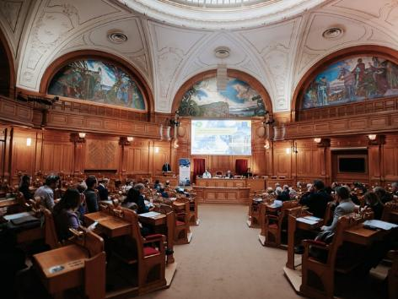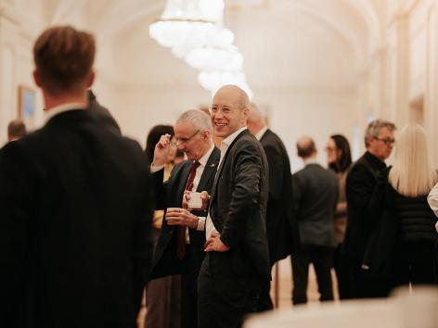

**IPM22, Parliament of Germany, Berlin, October 2022**

Ein Bild, das Kleidung, Person, Arbeitskleidung, Blue Collar enthält.
](https://www.flickr.com/photos/eufores/albums/)**Ein Bild, das Menschliches Gesicht, Lächeln, Text, Kleidung enthält.
Ein Bild, das Menschliches Gesicht, Lächeln, Text, Kleidung enthält.
Ein Bild, das Menschliches Gesicht, Lächeln, Text, Kleidung enthält.
**

For more impressions please check:

<https://www.flickr.com/photos/eufores/albums>

[Grab your reader’s attention with a great quote from the document or use this space to emphasize a key point. To place this text box anywhere on the page, just drag it.]

Sponsorship Packages

**Platinum Sponsor**

Before the conference

* **Logo** as “**Platinum Sponsor**”:
  + on the **EUFORES homepage** with a link to your website
  + in the **invitation e-mail** with a link to your website (invitation + at least 2 reminders to more than 1,200 renewables - and energy efficiency-related MEPs + MPs of all EU27 Parliaments)
  + in the **invitation letter postal mailing** (invitation to Presidents of Parliaments and all energy related committees in all EU27 Parliaments)

**During the conference**

* Participation of **4 delegates** from your organisation
* **3 items** of your organisation included in the EUFORES conference bag:
  + **1 brochure** of your corporate design – *provided by sponsor*
  + **2 items** of your corporate design (i.e. USB stick, pens, notepads) - *provided by sponsor*
* **Logo** as “**Platinum Sponsor**”:
  + in the **conference programme**
  + on the **conference screen**
  + on the **conference banner**
  + **VIP seating** for 1 delegate at the **Gala Dinner**
  + **Welcome address** of your high-level representative at the Gala Dinner

After the conference

* **Logo** as “**Platinum Sponsor**”:
  + on the **EUFORES homepage** with link to your website
  + in the **follow-up e-mail** with a link to your website

Sponsorship Packages

**Gold Sponsor**

**Before the conference**

* **Logo** as “**Gold Sponsor**”:
  + on the **EUFORES homepage** with a link to your website
  + in the **invitation e-mail** with link to your website (invitation + at least 2 reminders to more than 1,200 renewables - and energy efficiency-related MEPs + MPs of all EU27 Parliaments)
  + in the **invitation letter postal mailing** (invitation to Presidents of Parliaments and all energy related committees in all EU27 Parliaments)

**During the conference**

* Participation of **3 delegates** of your organisation
* **2 items** of your organisation included in the EUFORES conference bag:
* **1 brochure** of your corporate design – *provided by sponsor*
* **1 item** of your corporate design (i.e. USB stick, pens, notepads) - *provided by sponsor*
* **Logo** as “**Gold Sponsor**”:
  + in the **conference programme**
  + on the **conference screen**
  + on the **conference banner**
* **VIP seating** for 1 delegate at the **Gala Dinner**

**After the conference**

* **Logo** as “**Gold Sponsor**”:
  + on the **EUFORES homepage** with link to your website
  + in the **follow-up e-mail** with link to your website

Sponsorship Packages

**Silver Sponsor**

**Before the conference**

* **Logo** as “**Silver Sponsor**”:
  + on the **EUFORES homepage** with link to your website
  + in the **invitation e-mail** with link to your website (invitation + at least 2 reminders to more than 1,200 renewables - and energy efficiency-related MEPs + MPs of all EU27 Parliaments)
  + in the **invitation letter postal mailing** (invitation to Presidents of Parliaments and of all energy related committees in all EU27 Parliaments)

**During the conference**

* Participation of **2 delegates** of your organisation
* **Logo** as “**Silver Sponsor**”:
  + in the **conference programme**
  + on the **conference screen**
  + on the **conference banner**
* **1 item** of your organisation included in the EUFORES conference bag:
  + **1 brochure** of your corporate design – *provided by sponsor*

**After the conference**

* **Logo** as “**Silver Sponsor**”:
  + on the **EUFORES homepage** with link to your website
  + in the **follow-up e-mail** with link to your website

Sponsorship Packages

**Special Sponsor for**

**The Gala Dinner**

IPM25 will also offer one special sponsorship opportunity for the gala dinner, which will be held in an impressive venue in Brussels. The sponsorship will give your organization a chance to address the participants in a short welcome speech which is a unique opportunity to present your own point of view on the developments and needs of your sector to key policymakers.

**Before the conference**

* + Logo as “Gala Dinner Sponsor” on the EUFORES homepage with link to your website
  + Logo as “Gala Dinner Sponsor” in the invitation e-mail with link to your website (invitation + at least 2 reminders to more than 1,200 renewables - and energy efficiency-related MEPs + MPs of all EU27 Parliaments)
  + Logo as “Gala Dinner Sponsor” in the invitation letter postal mailing (invitation to Presidents of Parliaments and of all energy related committees in all EU27 Parliaments)

**During the conference**

* + **Welcome address of your high-level representative at the Gala Dinner**
  + Participation of 2 delegates of your organisation
  + Logo as “Gala Dinner Sponsor” in the conference programme
  + Logo as “Gala Dinner Sponsor” on the conference screen
  + Logo as “Gala Dinner Sponsor” on the conference banner
  + Logo as “Gala Dinner Sponsor” on the invitation card to the Gala Dinner inside the EUFORES conference bag
  + VIP seating for 1 delegate at the Gala Dinner

**After the conference**

* + Logo as “Gala Dinner Sponsor” on the EUFORES homepage with link to your website
  + Logo as “Gala Dinner Sponsor” in the follow-up e-mail with link to your website (to more than 1,200 RES-related MEPs + MPs of all EU27 Parliaments)

Sponsorship Packages

**Lunch Break Sponsor**

**Only for 20 March 2025 – European Parliament**

**Before the conference**

* + **Logo** as “**Lunch Break Sponsor**” on the EUFORES homepage with link to your website

**During the conference**

* + **Participation** of **1 delegate** of your organisation
  + **Logo** as “**Lunch Break Sponsor**” in the conference programme
  + **Logo** as “**Lunch Break Sponsor**” on the table cards during the coffee breaks

**After the conference**

* + **Logo** as “**Lunch Break Sponsor**” on the EUFORES homepage with link to your website
  + **Logo** as “**Lunch Break Sponsor**” in the follow-up e-mail with link to your website (to more than 1,200 RES-related MEPs + MPs of all EU27 Parliaments)

Sponsorship Packages

**Coffee Break Sponsor**

**Only for 20 March 2025 – European Parliament**

**Before the conference**

* + **Logo** as “**Coffee Break Sponsor**” on the EUFORES homepage with link to your website

**During the conference**

* + **Participation** of **1 delegate** of your organisation
  + **Logo** as “**Coffee Break Sponsor**” in the conference programme
  + **Logo** as “**Coffee Break Sponsor**” on the table cards during the coffee breaks

**After the conference**

* + **Logo** as “**Coffee Break Sponsor**” on the EUFORES homepage with link to your website
  + **Logo** as “**Coffee Break Sponsor**” in the follow-up e-mail with link to your website (to more than 1,200 RES-related MEPs + MPs of all EU27 Parliaments)

Sponsorship Packages

**Conference Folder Sponsor**

**Only for 20 March 2025 – European Parliament**

**Before and after the conference**

* + **Logo** as “**Conference Folder Sponsor**” on the **EUFORES homepage** with link to your website

**During the conference on 20 March 2025**

* + **Logo** on the Conference Folder – to be used during the conference on 20 March 2025
  + Participation of **1 delegate** of your organisation on both days

Sponsorship Packages

**Badges Sponsor**

**Only for 20 March 2025 – European Parliament**

**Before and after the conference**

* + **Logo** as “**Badges Sponsor**” on the **EUFORES homepage** with link to your website

**During the conference**

* + **Logo** on the **name tag** – to be used during the conference on 20 March 2025
  + Participation of **1 delegate** of your organization on both days

**SPONSORSHIP CHECKLIST**

**The table offers an overview of EUFORES sponsorship packages and the related benefits and prices**

| **Sponsorships table** | **Platinum** | **Gold** | **Silver** | **Gala dinner** | **Coffee or Lunch Break** | **Folder** | **Badges** |
| --- | --- | --- | --- | --- | --- | --- | --- |
| **NON-MEMBERS**  **MEMBERS** | **€25.000**  **€23.000** | **€18.000**  **€16.000** | **€12.000**  **€10.000** | **€18.000**  **€16.000** | **€8.000**  **€7.000** | **€12.000**  **€10.000** | **€12.000**  **€10.000** |
| **Before the conference** | | | | | | | |
| Logo on EUFORES homepage with link to your website |  |  |  |  |  |  |  |
| Logo in the invitation with link to your website  *(invitation + at least 2 reminders to more than 1,200 energy efficiency related MEPs + MPs of all EU27 Parliaments) |  |  |  |  |  |  |  |
| Logo in the invitation letter postal mailing (invitation to Presidents of Parliaments and of all energy related committees in all EU27 Parliaments) |  |  |  |  |  |  |  |
| **During the conference** | | | | | | | |
| Participation of delegates of your organisation  1 |  |  |  |  |  |  |  |
| 2 |  |  |  |  |  |  |  |
| 3 |  |  |  |  |  |  |  |
| 4 |  |  |  |  |  |  |  |
| Possibility to include items of your organisation in the conference bag (ex. brochure, USB stick, pens, notepads provided by sponsor) |  |  |  |  |  |  |  |
| 1 |  |  |  |  |  |  |  |
| 2 |  |  |  |  |  |  |  |
| 3 |  |  |  |  |  |  |  |
| Logo in the conference programme |  |  |  |  |  |  |  |
| Logo on the conference screen |  |  |  |  |  |  |  |
| Logo on the conference banner |  |  |  |  |  |  |  |
| Logo as “Gala Dinner Sponsor” on the invitation card of the Gala Dinner inside the EUFORES conference bag |  |  |  |  |  |  |  |
| VIP seating for 1 delegate at the Gala Dinner |  |  |  |  |  |  |  |
| **Welcome address of your high-level representative at the Gala Dinner** |  |  |  |  |  |  |  |
| Logo as “Coffee Break Sponsor” on the table cards |  |  |  |  |  |  |  |
| Logo as “Lunch Break Sponsor” on the table cards |  |  |  |  |  |  |  |
| Logo on the conference folder – to be used during the conference and afterwards |  |  |  |  |  |  |  |
| Logo on the name tag – to be used during the whole conference |  |  |  |  |  |  |  |
| **After the conference** | | | | | | | |
| Logo on EUFORES homepage with link to your website |  |  |  |  |  |  |  |
| Logo in the follow-up e-mail with link to your website (to more than 1,200 renewables - and energy efficiency-related MEPs + MPs of all EU27 Parliaments) |  |  |  |  |  |  |  |

**SPONSORSHIP CONTRACT FOR IPM25**

**EUFORES 25th Inter-Parliamentary Meeting**

**on Renewable Energy and Energy Efficiency**

**20 – 21 March 2025 - European Parliament, Brussels and**

**the House of Representatives of Belgium, Brussels**

|  |  |  |
| --- | --- | --- |
|  | Non-Members* | Members* |
| Platinum Sponsor package | €25.000 | €23.000 |
| Gold Sponsor package | €18.000 | €16.000 |
| Silver Sponsor package | €12.000 | €10.000 |
| ~~Special Sponsor for the Gala Dinner~~ | ~~€18.000~~ | ~~€16.000~~ |
| ~~Lunch Break Sponsor~~ | ~~€8.000~~ | ~~€7.000~~ |
| Coffee Break Sponsor | €8.000 | €7.000 |
| Conference Bags Sponsor | €12.000 | €10.000 |
| Badges Sponsor | €12.000 | €10.000 |
|  |  |  |

|  |  |  |  |  |
| --- | --- | --- | --- | --- |
| Organisation |  | | | |
| Contact Person |  | | | |
| Address |  | | | |
| Telephone |  |
| Email |  | | | |
| Website |  | | Vat No. |  |
| Date |  | | | |
| Signature: |  | | Stamp: |  |

* Amounts excluding VAT (21% VAT will be added where applicable).

A discounted rate will be applied in case you decide to become a member of EUFORES. In case of cancellation of IPM due to force majeure, fees are not refundable. For more information, please visit our website: [www.eufores.org](http://www.eufores.org)

**PREVIOUS SPONSORS**

EUFORES aims to build and maintain a good relationship with sponsors, working closely with them to ensure high-professional conduct, becoming a good ambassador for the company image by offering them 100% professional content (pictures) for their social media channels updates.

*You don’t need to update the world on your every move, but keeping the world updated on your activities, keeps the world interested!*

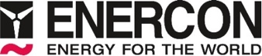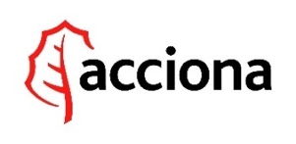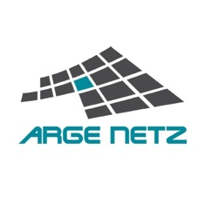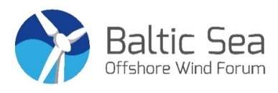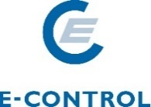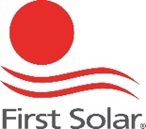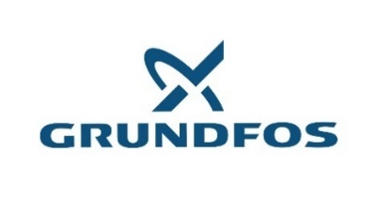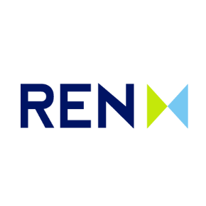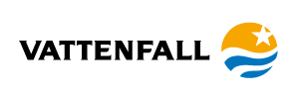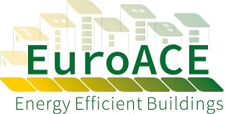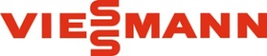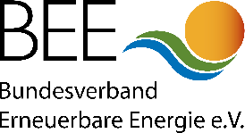

## [**CONTACT US**](https://eufores.org/contact/)

EUFORES is the European parliamentary network for renewable energy and energy efficiency with members from all major political groups in the European Parliament as well as in the EU27 national Parliaments.

EUFORES promotes the deployment of renewable energy and energy efficiency within Europe. To this purpose it organizes various events to offer Parliamentarians and other key players an opportunity to exchange views. The annual Inter-Parliamentary Meeting is EUFORES’ largest event with usually 100 Members of Parliaments from all over Europe.

Parliamentarians are key actors when it comes to drafting legislation for renewable energy and energy efficiency, which is crucial for developing an effective and stable framework for market development in those sectors.

Dr. Jan Geiss

Secretary General

EUFORES

Tel.: +32 (2) 546 1948

[jan.geiss@eufores.org](mailto:jan.geiss@eufores.org)

Ein Bild, das Menschliches Gesicht, Person, Kleidung, Lippe enthält.

Sylvia Guarente

Project and Event Assistant

EUFORES

Tel.: +32 (2) 400 1027

[sylvia.guarente@eufores.org](mailto:sylvia.guarente@eufores.org)



**@EUFORES_EU**